PRECRIME

Bachelor of Engineering in Information Technology
by
Nitesh Mistry
Imran Memon
Asim Shaikh
Under the Guidance of
Prof. Gayatri Dantal



SHREE L. R. TIWARI COLLEGE OF ENGINEERING, MIRA ROAD
(Approved by AICTE, Govt. of Maharashtra & Affiliated to University of Mumbai)

DEPARTMENT OF INFORMATION TECHNOLOGY
2013-14

PROJECT REPORT
ON
PRECRIME

Submitted in partial fulfillment of the requirements for the degree of
BACHELOR OF ENGINEERING
by
Nitesh Mistry
Imran Memon
Asim Shaikh
Under the Guidance of
Prof. Gayatri Dantal

SHREE L. R. TIWARI COLLEGE OF ENGINEERING, MIRA ROAD
(Approved by AICTE, Govt. of Maharashtra & Affiliated to University of Mumbai)
DEPARTMENT OF INFORMATION TECHNOLOGY
2013-14
SHREE L. R. TIWARI COLLEGE OF ENGINEERING,MIRA ROAD
(Approved by AICTE, Govt. of Maharashtra & Affiliated to University of Mumbai)
Department of Information Technology
UNIVERSITY OF MUMBAI
CERTIFICATE
This is to certify that the project titled “PreCrime” has been partially completed under our supervision and guidance by the following students:
Nitesh Mistry
Imran Memon
Asim Shaikh
In the partial fulfillment of degree of Bachelor of Engineering in Information and Technology branch as prescribed by the University of Mumbai during the academic year 2013-2014. The said work has been assessed and is found to be satisfactory.

Signature of the Internal Examiner Signature of the External examiner
Name: _____________ Name: ______________
Date: _____________ Date: _______________
Signature of the Coordinator Signature of the HOD
Name: _____________ Name: ______________
Date: _____________ Date: _______________

Dr. S. Ram Reddy
Principal

ACKNOWLEDGEMENTS

A few sublime human experiences defy expressions of any kind, and a feeling of true gratitude is one of them. I, therefore, find words quite inadequate to express my indebtedness to my Guide Prof. Gayatri Dantal for her virtuous guidance, encouragement and help throughout this work. Their deep insight into the problem and the ability to provide solutions has been immense value in improving the quality of project at all stages. This experience of working with them shall ever remain a source of inspiration and encouragement for me.
I express my thanks to Prof. Gayatri Dantal, HOD (IT), SLRTCE, Mira Road , for extending her support that she gave truly help the progression of the project work. I express my thanks to Prof. Anil Chaturvedi, Asst. Prof., SLRTCE, Mira Road for extending his support.
My sincere thanks to Dr. P. V. Pradhan, Director and Dr. S. Ram Reddy, Principal , SLRTCE , Mira Road for providing me the necessary administrative assistance in the completion of the work.
I am extremely grateful to the celebrated authors whose precious works have been consulted and referred in my project work. I also wish to convey my appreciation to my friends who provided encouragement and timely support in the hour of need.
Special thanks to my Parents whose love and affectionate blessings have been a constant source of inspiration in making this a reality.
All the thanks are, however, only fraction of what is due to Almighty for granting me an opportunity and the divine grace to successfully accomplish this assignment.

Prof. Gayatri Dantal

Nitesh Mistry Asim Shaikh Imran Memon
INTRODUCTION
As ensuring public security is becoming important part of any government, our project is based on system that analyses criminal data. Our windows system is used mainly to overcome problem faced by present system that is based on manual work on papers to analyse data, which is insufficient of predicting or forecasting anything. Our system is based on data mining that will use data stored in database and represents them in easy way to understand tabular, graphical form.
National surveys demonstrate that millions of crimes go unreported. Several reasons may contribute to this lack of reporting and we are investigating these potential reasons and how they may be addressed. We are developing an android application that provides an anonymous and secure mechanism for both victims and witnesses to report crimes to police.

AIMS AND OBJECTIVES
The mission of PreCrime is simple: place officers at the right time and location to give them the best chance of preventing crime.
Our windows system is based on data mining that will use data stored in database to analyse the criminal data and to predict and forecast the upcoming crimes. Which will be highlighted in the Google Maps and represented in tabular and graphical form.
Our android application that provides an anonymous and secure mechanism for both victims and witnesses to report the ongoing crimes to police. The proposed system will automatically inform the on-duty police officers and provide searchable overviews for the public at large.
We believe police and people might find such as system a convenient alternative for forecasting and reporting crime.

LITERATURE SURVEYED
National surveys demonstrate that millions of crimes go unreported. Several reasons may contribute to this lack of reporting and we are investigating these potential reasons and how they may be addressed. We are developing an online system that provides an anonymous and secure mechanism for both victims and witnesses to report crimes to police. The system is implemented and tested in the US. Potential users were surveyed to determine their intent to use the system. Respondents found the online system useful, accessible, and safe to report crime, but the type of crime and the urgency of response is a determinant in the decision to use the system versus reporting it to a live person.

EXISTING SYSTEMS
- RAPID INFORMATION OVERLAY TECHNOLOGY (RIOT)
Raytheon, a major American defense contractor has secretly developed software capable of tracking people's movements and predicting future behavior by mining data from social networking websites.
Using Riot it is possible to gain an entire snapshot of a person's life – their friends, the places they visit charted on a map – in little more than a few clicks of a button.
Riot pulls out this information, showing not only the photographs posted onto social networks by individuals, but also the location at which the photographs were taken.
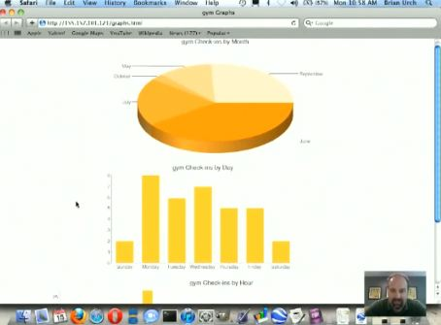
A look into the specifics of user’s daily schedule based on check-in trends.
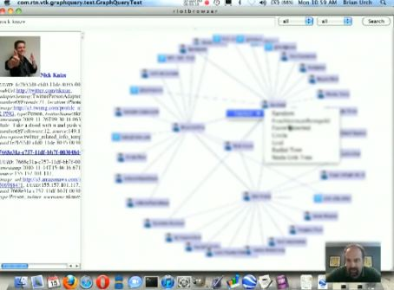
A web of user’s connections with other people. Some phone numbers were included too.

- CLEAR
Thomson Reuters has created “CLEAR®”, an investigative suite that can be used for pre-crime detecting. The company recently released a research white paper done by its Fraud Prevention and Investigation unit. The white paper explores the growth, use, and legal and privacy challenges of pre-crime detecting, and examines the use of such capabilities in the forecasting of criminal activity.
CLEAR has both public and proprietary records, arrest and incarceration records, photo lineups, work affiliations data, and other resources, and the methodology of its “Web Analytics” to search and categorize social media, blogs, news sites and watch lists. Such public and proprietary records are then integrated into the user’s systems or searched via online platforms. Such integration can be done with large-volume batch capabilities and batch alerting functionality to identify and intercept individuals and/or organizations likely to participate in criminal activity.

- PREDPOL
A map of a city is marked up with small red squares, each indicating a 500-by-500-foot zone where crimes are likely to take place next. A heat-map mode shows even more precisely where cars may be stolen, houses robbed, people mugged.
The program is called PredPol, and it calculates its forecasts based on times and locations of previous crimes, combined with sociological information about criminal behavior and patterns.

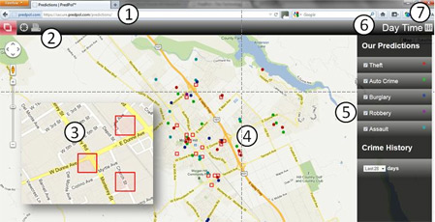

- TWEETSTRAP
The goal of this project is to “Tweetstrap”/bootstrap a marketer to find the twitter mini-celebrities (beyond the “usual suspects”) to target to help market his test tweet. The predictions are done based on the influence source of the tweet i.e. popularity of the source tweeter, the length of the cascade chains that the tweet generated and also analysis of the content of the tweets (topics from the words or links it contains).
The aim is to develop a regression model (support vector based) that will predict the popularity of a tweet (by giving retweet counts), factoring in various attributes of tweets from a training set for each celebrity user.
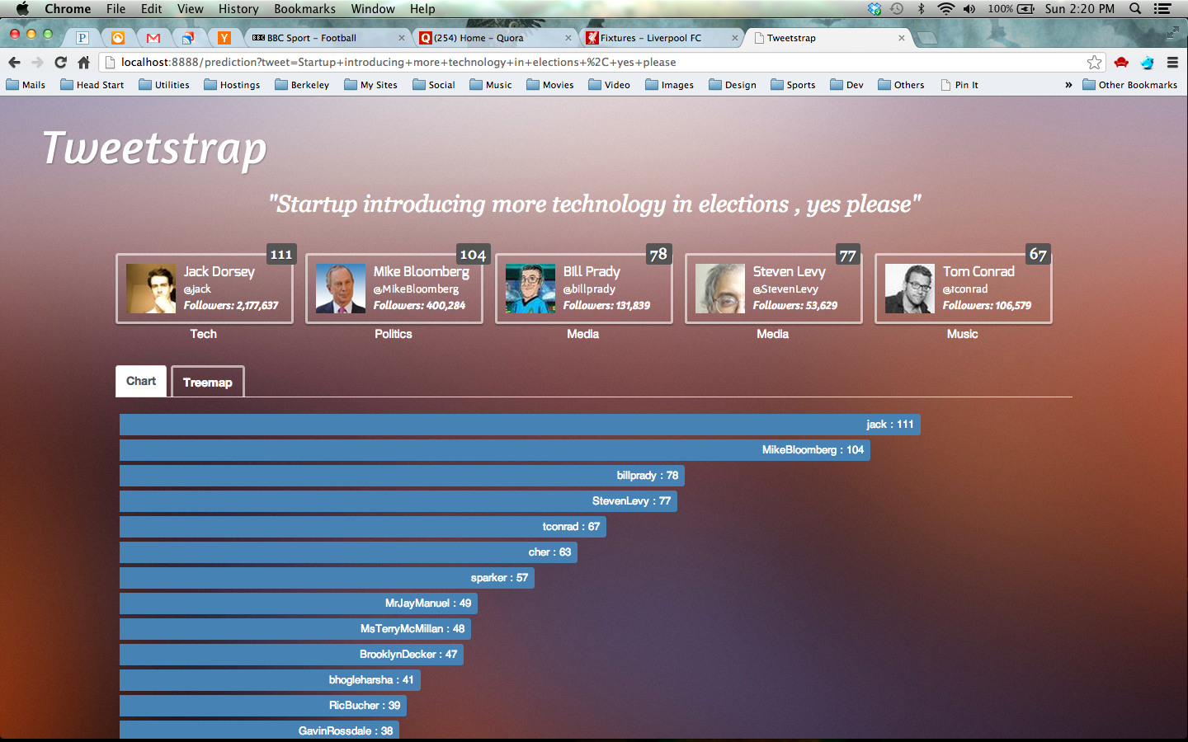
Histogram visualization
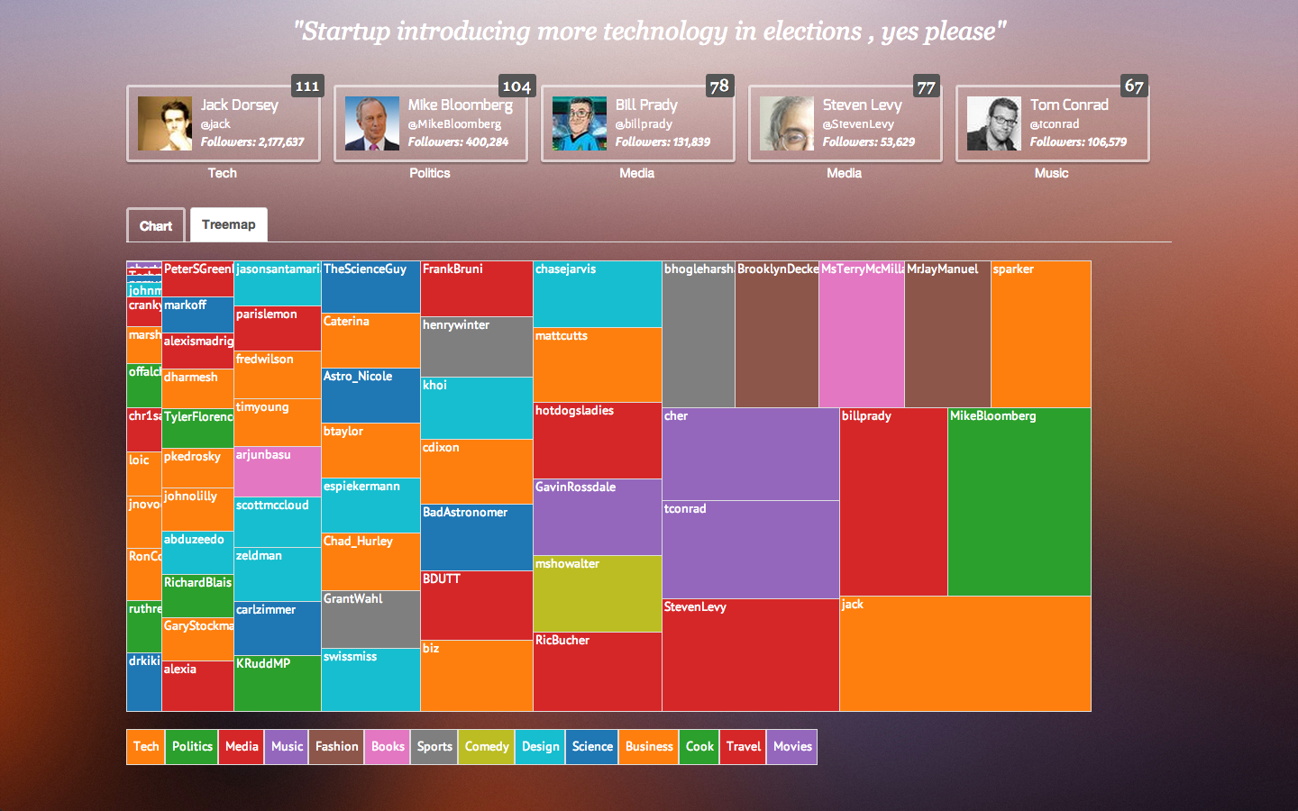
Treemap Visualization

SCOPE
The windows based system and both the database will be present at the police station and accessible by the authorized police officer.

The android application will accessible by the citizen and police officer the report the ongoing crime and to get information about the crime respectively.

PROPOSED SYSTEMS
The database will contain the past criminal records which will be used by our windows system for data mining that will be analysed to predict and forecast the upcoming crimes. The results will be highlighted in the Google Maps and represented in tabular and graphical form.
The data entered will be pre-processed by performing operations like cleaning, integration, transformation, reduction and discretization. This data will be used for predicting the future crimes. The system will help the police to place the officers at the right time and at the right place to give them the best chance to prevent crime.
The other database that will contain the Adhar card number of the registered users, that will act as a unique identifier in case of false alarm. Our android application that will provide an anonymous and secure mechanism for both victims and witnesses to report the ongoing crimes to police.
The proposed system will authenticate the report and if found true, will automatically inform the on-duty police officers and provide searchable overviews for the public at large. And if found false police can take serious actions against the sender of the report using its Adhar card number.

HARDWARE AND SOFTWARE
SOFTWARE REQUIREMENTS FOR PC:
Operating System: Windows XP or higher.
Application Packages:
1. Dot Net Framework
2. Google API

HARDWARE REQUIREMENTS FOR PC:
1. Processor: Intel Pentium IV or higher
2. RAM: 1 GB or higher

SOFTWARE REQUIREMENTS FOR MOBILE:
Operating System: Android Gingerbread (2.3) or higher.

HARDWARE REQUIREMENTS FOR MOBILE:
1. Processor Speed: Above 1 GHz
2. RAM: 512 MB or higher
3. Internet Connectivity

Front end: ASP.NET
Back end / Database: SQL SERVER

METHODOLOGY
Two applications has to be developed. Windows based application will be used by authorized police officer and Mobile application used by the citizens to report the ongoing crime and police officers to get notifications about crime.
Following are the functions of two applications:

- Windows application
- Accept report from android application
- Verify the report is true or false alarm
- Inform nearby police officers
- Take past crime records
- Process the records
- Predict from records
- Highlight predicted data in the Google Maps
- Represented it in a tabular and graphical form

- ANDROID APPLICATION
- Register user with Adhar card number
- Identify longitude and latitude of the user
- Generate report
- Send report to the police station server

DESIGN DETAILS
DATA FLOW DIAGRAMS

- Zero level DFD
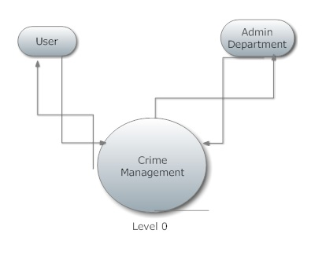

- Level one DFD
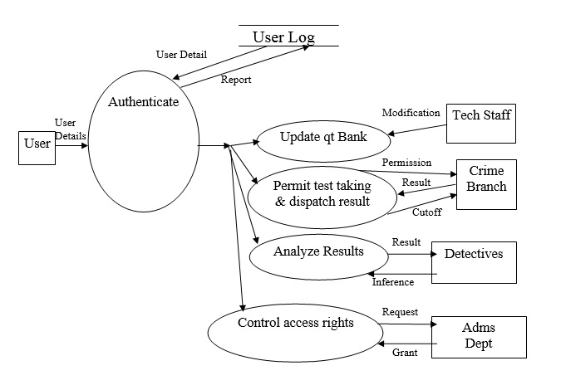

- Level two DFD for authenticate

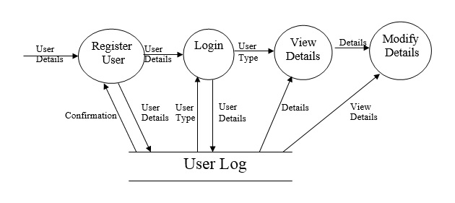

USE CASE DIAGRAM
- Android Application
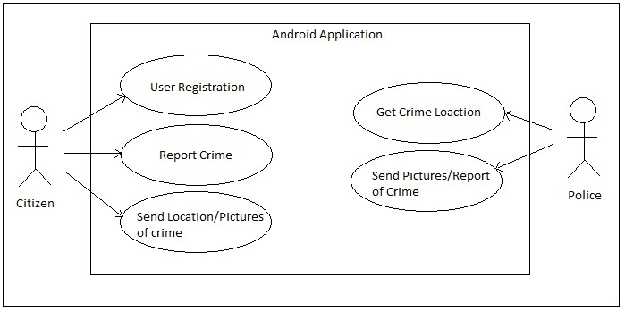

- Windows Application
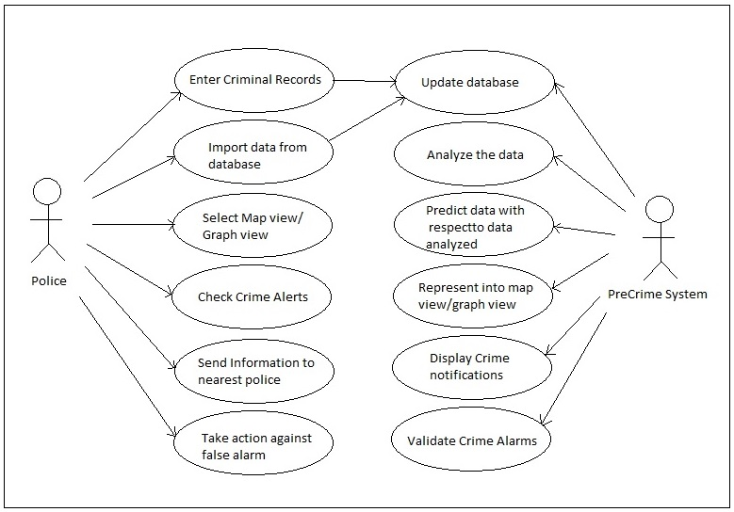
ER DIAGRAM
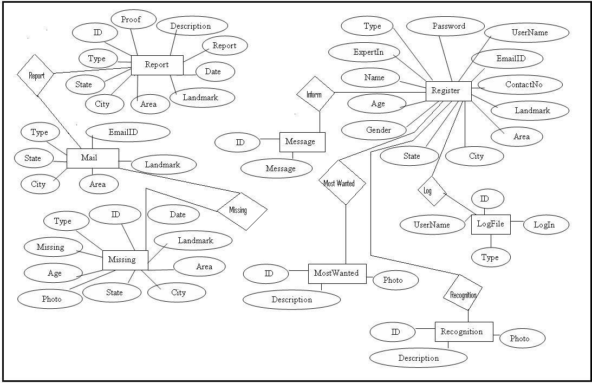
Implementation Plan for next semester
DEVELOPMENT STAGES
- Development of Windows Application
- Development of Android Application
- Testing both applications individually
- Implement connection between Windows Application and Android Application
- Test whole system after integration
- Enhancement
- Code and project size reduction
- Quality improvement
- Performance and speed improvement

References
- RIOT
- http://www.nowtheendbegins.com/blog/?tag=rapid-information-overlay-technology
- http://www.marketoracle.co.uk/Article40937.html

- CLEAR
- http://www.hendonpub.com/law_and_order/articles/2013/06/precrime_detecting

- PREDPOL
- http://edition.cnn.com/2012/07/09/tech/innovation/police-tech/index.html
- http://www.predpol.com/

- TWEETSTRAP
- http://www.kurzweilai.net/minority-report-style-pre-crime-prediction-using-twitter-data-possible

